Customer Journey Map
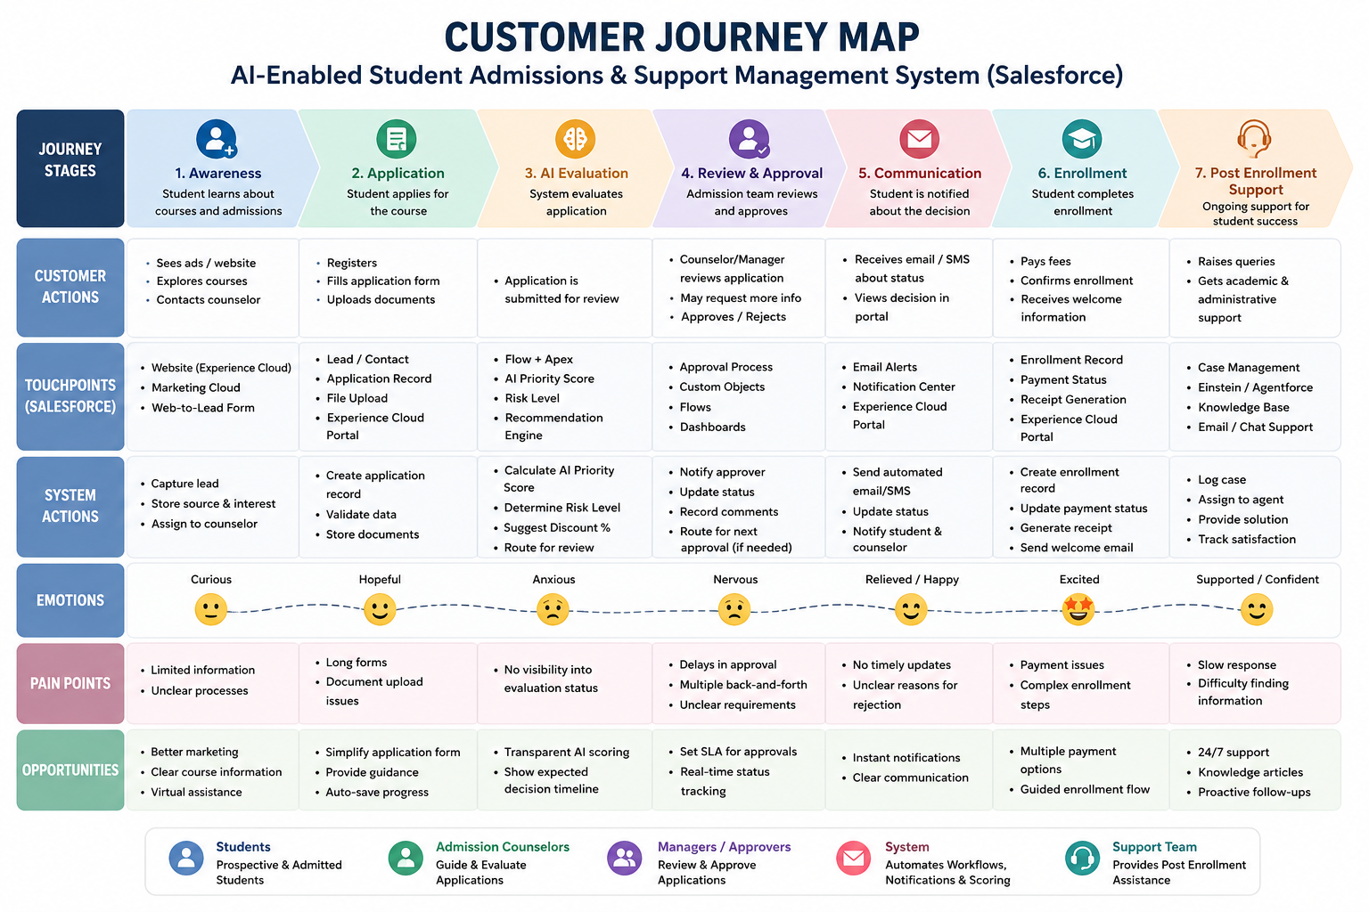
A Customer Journey Map (CJM) is a visual representation of the complete experience a customer has while interacting with a product, service, or organization. It illustrates every stage of the customer's journey, from the initial awareness of the service to post-service support, helping organizations understand customer needs, expectations, and pain points at each step.
In the AI-Enabled Student Admissions System, the customer journey map represents the experience of a prospective student throughout the admission process. The journey begins when the student explores available courses and registers on the admission portal. The student then submits the application and required documents, after which the AI-powered system evaluates the application by calculating priority scores, identifying risk levels, and generating recommendations. Admission officers review the AI-generated insights, verify the application, and make approval decisions. Throughout the process, automated notifications keep students informed about their application status. After successful admission, the system continues to provide support through AI assistants, case management, and communication services.
Creating a customer journey map helps identify opportunities to improve the admission process by reducing delays, enhancing communication, automating repetitive tasks, and providing a personalized experience. It also enables institutions to understand student expectations, optimize Salesforce workflows, and deliver faster, more transparent, and efficient admission services.

